What is HTML?

Hyper Text Markup Language is a scripting language that defines the structure and content of web pages.

What is HTTP?

HTTP stands for Hypertext Transfer Protocol, and it's a protocol that allows web clients to request resources from web servers.

what is difference between http and https?

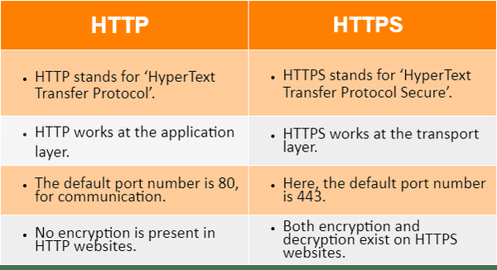

what is use of anchor tag?

The <a> HTML element (or anchor element), with its href attribute, creates a hyperlink to web pages, files, email addresses, locations in the same page, or anything else a URL can address.

what is use of href?

The href attribute used to link to another web page on the same domain or a different domain. href can also be used for other things, like linking to a different part of the same page, or serving a different web protocol than HTTPS.

what is difference between anchor tag and href?

Anchor tag is used to link another web page but, href is a attribute which we use for url of specification and location of linked document.

what Is diff between cellspacing and cellpadding?

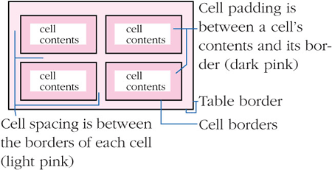

How many types of css are there?

[1. Inline CSS](https://www.geeksforgeeks.org/types-of-css-cascading-style-sheet/#inline-css)

[2. Internal or Embedded CSS](https://www.geeksforgeeks.org/types-of-css-cascading-style-sheet/#internal-or-embedded-css)

[3. External CSS](https://www.geeksforgeeks.org/types-of-css-cascading-style-sheet/#external-css)

what is the difference between internal and external css?

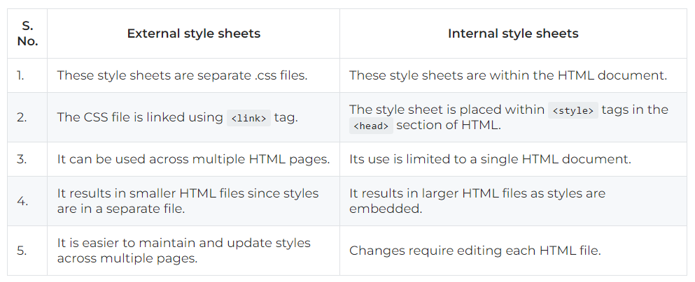

what selectors are used in css?

1. Universal Selector ( * )
2. Element Selector ( Element name (p/h1/div) )
3. ID selector ( #id_name )
4. Class Selector ( .class_name )
5. Attribute selector ( a[attribute] )
6. Child/Descendant (parent > child),(parent child)
7. Pseudo class (:hover)
8. Nth child ( nth-child(n) )

What selectors are used in JS?

1. ID selector

document.getElementById(‘myId’);

1. Class Selector

document.getElementByClassNames(‘ClassName’);

1. Tag Selector

document.getElementByTagNames(‘div’);

1. Querry Selector

querySelector(‘.myClass);

//Select First matching element

1. Querry Selector All

querySelectorAll(‘div.myclass’);

//Select all matching elements

what is difference between var and let variable

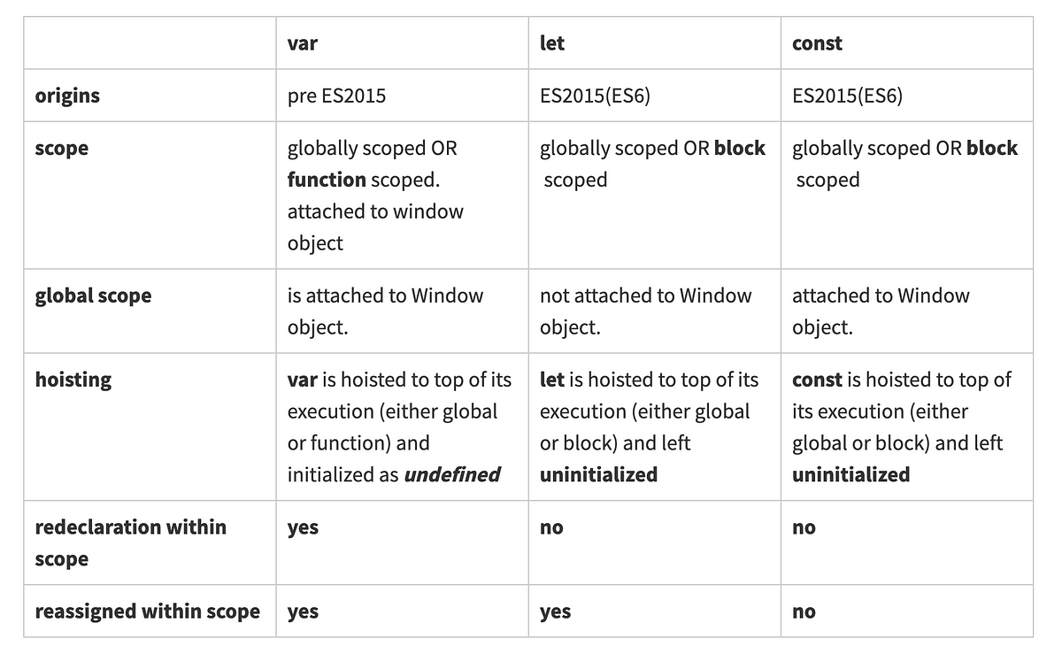

What is use of const variable?

The const variable in JavaScript is used to declare a variable that is meant to remain constant

What is use of getElementById ?

1. Selecting elements
2. Accessing properties and methods

const element = document.getElementById('myElementId');

element.innerHTML = 'Hello, World!'; // Change the inner HTML

element.style.color = 'blue'; // Change the text color

Difference between server side scripting language and client side scripting language

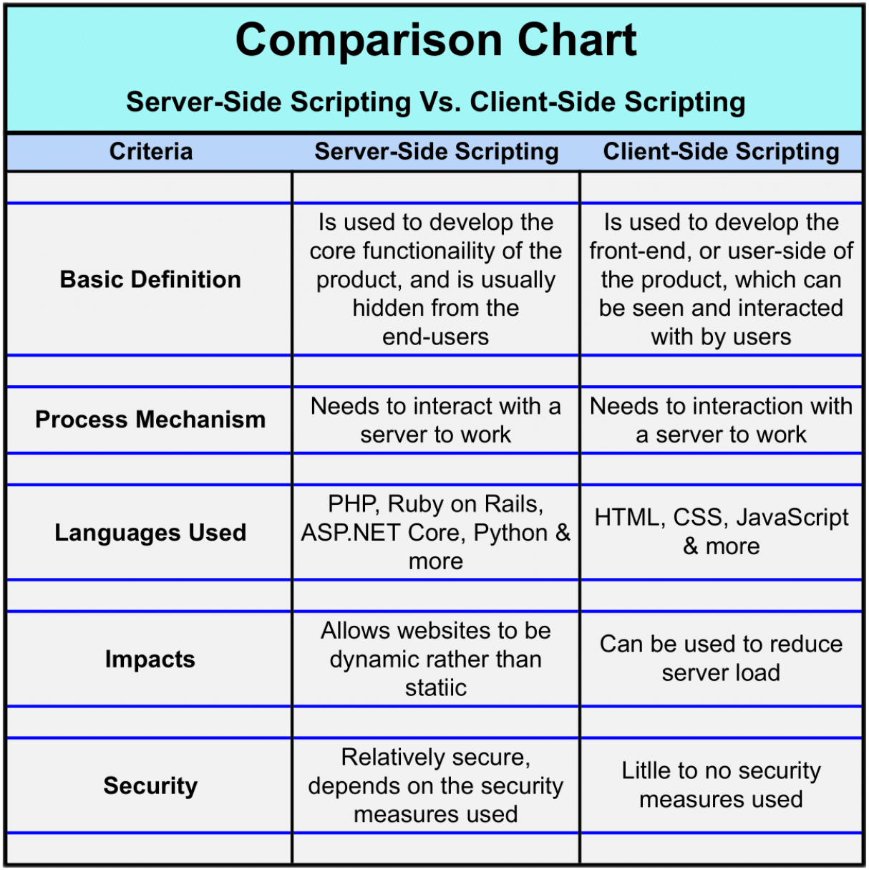

Advantages of Bootstrap

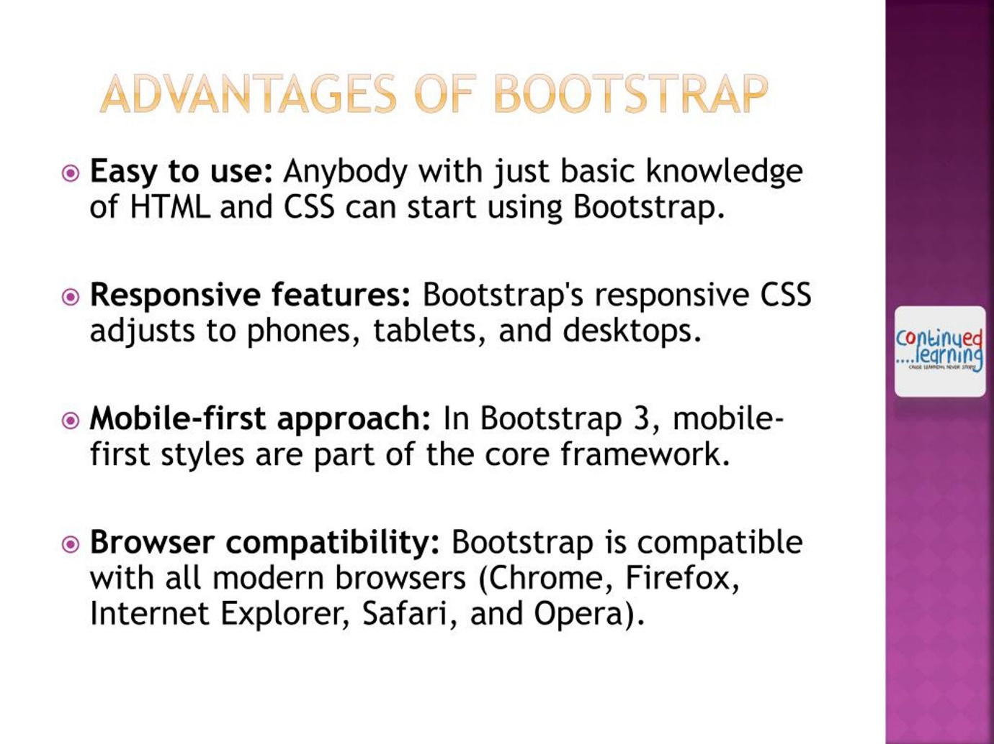

How we can give background color ti navbar using bootstrap

Choose from .navbar-light for use with light background colors, or .navbar-dark for dark background colors.

Can we talk to web server using javascript ?

While JavaScript is a client-side language, it can effectively interact with web servers to send and receive data, enhancing the user experience and enabling dynamic web applications. This capability is a key aspect of modern web development.

1. AJAX( asynchronous java script and xml)

**Example**: Using fetch or XMLHttpRequest to retrieve data from a server or submit data to a server.

2. WebSockets

**Example**: A chat application where messages can be sent and received instantly.

When there is HTML why we use JS

HTML and JavaScript serve different but complementary purposes in web development. Here’s why we use JavaScript alongside HTML:

**1. Interactivity**

* **HTML**: Primarily used for structuring content on the web (e.g., headings, paragraphs, images, links).
* **JavaScript**: Adds interactivity to that content, allowing users to engage with the webpage. For example, you can create buttons that respond to clicks, forms that validate input, and dynamic updates to the page content without refreshing.

**2. Dynamic Content**

* **HTML**: Static content is displayed as it is written in the document.
* **JavaScript**: Can dynamically change the content of the page based on user actions or other events. For example, it can update the DOM to display new data retrieved from a server.

**3. Event Handling**

* **HTML**: Does not handle events on its own.
* **JavaScript**: Can respond to user events (like clicks, key presses, and mouse movements) to perform actions such as displaying alerts, changing styles, or navigating to different parts of the page.

**4. Manipulating the DOM**

* **HTML**: Represents the structure of the web page.
* **JavaScript**: Allows you to manipulate the DOM (Document Object Model) to add, remove, or modify elements and attributes on the fly, enhancing the user experience.

**5. Control Flow and Logic**

* **HTML**: Lacks conditional logic or loops.
* **JavaScript**: Enables you to implement complex logic, control flow, and algorithms. For example, you can perform calculations, manage application state, or determine what content to display based on user input.

**6. Asynchronous Communication**

* **HTML**: Cannot communicate with a server or process data without a page reload.
* **JavaScript**: Can make asynchronous requests (e.g., using AJAX or Fetch API) to retrieve or send data to a server without disrupting the user experience.

**7. Enhanced User Experience**

* **HTML**: Provides structure and content.
* **JavaScript**: Enhances the overall experience by allowing for smooth animations, transitions, and real-time updates (like live chat features).

Diffrence between getelement by id classname and tag name

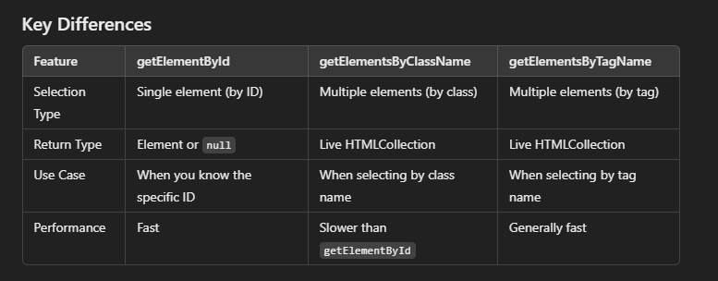

How we can create element using javascipt in html?

You can create new HTML elements using JavaScript by using the document.createElement method. Here’s a step-by-step guide on how to do this:

**Steps to Create an Element**

1. **Create the Element**: Use document.createElement to create a new element.
2. **Set Attributes or Content**: Modify the element by setting attributes, styles, or inner content.
3. **Append the Element to the DOM**: Use methods like appendChild or insertBefore to add the new element to an existing element in the document.

What is mean by group selectors in css

**group selectors** allow you to apply the same styles to multiple elements at once, helping to reduce redundancy and keep your stylesheet more efficient and organized.

Difference between alert and confirm dialog box

**Alert**: A simple dialog for displaying messages with a single "OK" button.

**Confirm**: A dialog that asks a question and provides "OK" and "Cancel" buttons, returning a boolean based on the user's choice.

Return type of prompt method

String (or null if canceled).

Return type of getElementByClassName

**HTMLCollection**: This is a live collection of elements that have the specified class name(s). It behaves like an array, but it's not a true array. You can access elements by index, but it does not have array methods like forEach or map.

**Live Collection**: The collection is "live," meaning it automatically updates if the document changes (e.g., if elements are added or removed that match the class name).

What is difference between absolute and relative position

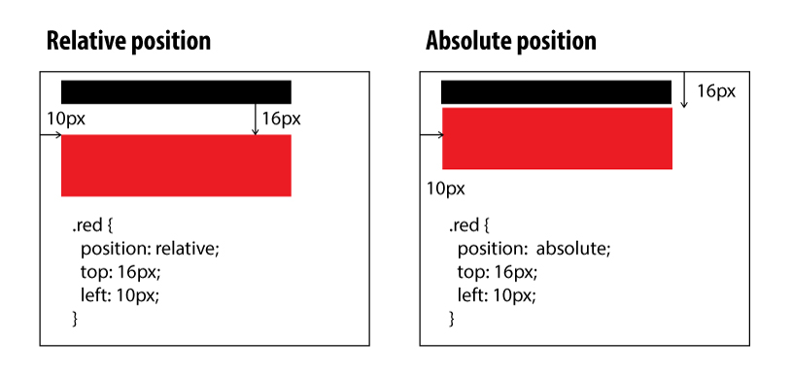

Difference between inner-html and text-content

<body>

<p id=”myp”> </p>

<script>

Var e = document.getElementById(“myp”);

e.textCotent = “<i>Hello</i>”; // it will show as it is

e.innerHTML=“<i>Hello</i>”;//it will show italic text

</script>

</body>

Difference between while and do while loop

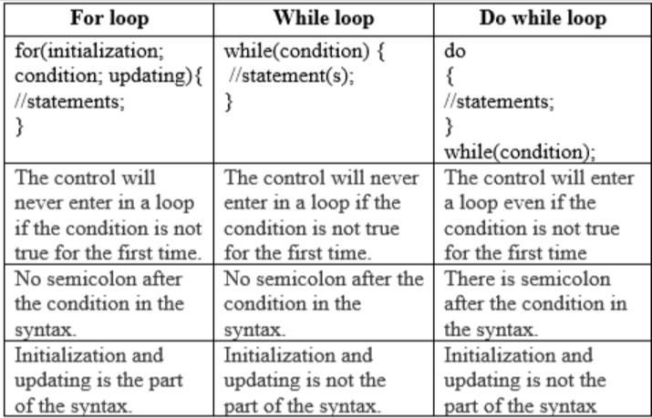

Types of Function ?

Anonymous Function

Arrow Function

Recursive Function

what is the use of recursive function

Recursive functions are valuable for solving complex problems, traversing data structures, implementing backtracking algorithms, and optimizing dynamic programming tasks.

Difference between javascript object vs array

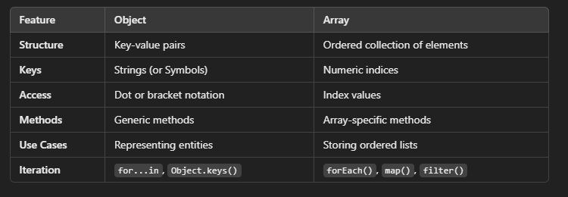

How we can define constructor in javascript ?

**Constructors** are functions that create objects and initialize properties.

They can be defined using function declarations or the class syntax.

Always use the new keyword when calling a constructor to create a new instance.

Use of this keyword in javascript

The this keyword in JavaScript is a special identifier that refers to the context in which it is being used. Its value can vary depending on how a function is called.